Activity B: Circuits

Declan Heard

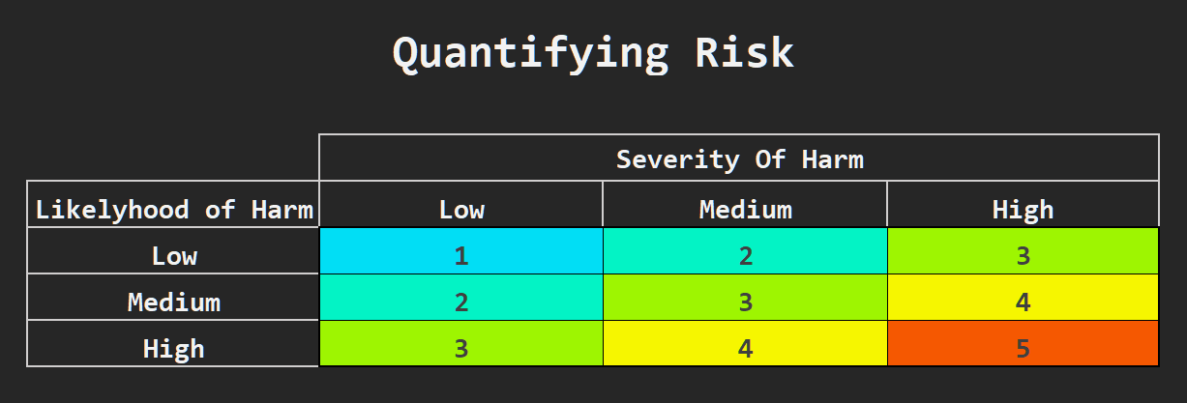Risk Assessment

#### Control Measures

### Hazard Elimination

### Substitution

### Use of Safety procedure

### Use of Warnings

### Use of PPE (Personal Protective Equipment)

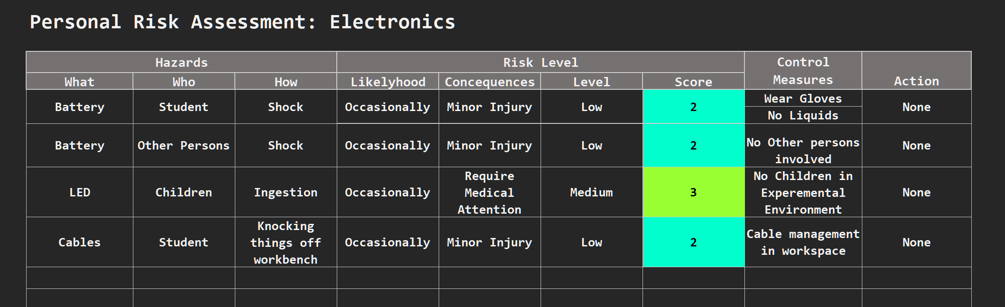

**Lab Book: Electronic Experiments**

#### 1: Resistances in Series & Parallel

# Purpose of Investigation

* Investigate Kirshkoffs XXX laws
* Collect experimental evidence to investigate the vailidity of Kishkoffs laws.

# Equipment Required

* Power Supply
* USB to Terminal Unit (Pre-Assembled with USB power to + and – Terminals)
* Resistor $0.1 Ω$
* M3 Nut
* Multimeter x2
* PP3 battery x2
* Pair of meter test leads x2
* Single Crocodile Clips x6
* Bulb Modules /w Bulbs x3
* Copper Strip & Steel Strip
* PH1 Philips head screwdriver
* Pliers

# Calculations Required

Ohms Law

$$V=IR$$

# Experimental Methodology

Set Up:

1. $0.1 Ω$ Resistor connected between -v and A terminal on USB terminal unit.

Question 1.1: Voltage Measurement

1. Connect the multimeter test probes across the +v and -v terminals.
2. Turn multimeter setting to DC voltage 20.
3. Power on the USB terminal unit by inserting USB connector into powered USB socket.
4. Allow circuit to settle for 10 seconds, then note displayed voltage reading
5. Power off circuit by unplugging USB from power source.
6. Connect the bulb module across the +v and -v terminals.
7. Power on circuit using USB power source.
8. Allow circuit to settle for 10 seconds, then note displayed voltage reading

Question 1.2 Current Measurement:

1. Disconnect the Red +v bulb module cable from the +v terminal, and connect directly to the multimeter common cable.
2. Insert multi meter positive test lead into the Amp input, and connect this cable to the +v terminal.
3. Turn multimeter setting to the maximum DC Current setting.
4. Power on the USB terminal unit by inserting USB connector into powered USB socket.
5. Turn multimeter current setting down step by step until a suitable range is displayed.
6. Allow circuit to settle for 10 seconds, then note displayed current reading.

# Observations regarding Setup

# Expected Outcomes

# Observations During Experimental Procedure

# Collected Data Summary

# Data Analysis

# Reflections on Outcome

# Other Notes & Observations

**Workbook: Activities**

# Question 1.1:

1. Measure the voltage Across the bulb module:

|  |  |
| --- | --- |
| **Circuit State** | **Voltage** |
| Without Bulb Module |  |
| With Bulb Module |  |

Question 1.2:

1. Measure the current through the bulb module:

|  |  |
| --- | --- |
| **Circuit State** | **Current** |
| Ampmeter In Series |  |

Question 1.3:

1. Measure the Voltage across the 0.1Ω resistor

|  |  |
| --- | --- |
| **Circuit State** | **Resistance** |
| 0.1Ω Resistor in Series |  |

1. Use ohms law to calculate the current flowing through the resistor:

Question 1.4:

1. Calculate Resistance of the bulb module

Question 1.5:

1. Given that we expect the current to be approximately 200 mA and that this

current is flowing through a 10 Ω resistor, what voltage should we expect to

measure, and which range should we use on the meter?

Question 1.6:

1. Measure Voltage across 10ohm resistor
2. Use Ohms law to calculate current flowing through resistor

Question 1.7

Can you recall the circuit law that describes the fact that current is the same at all points throughout the circuit?

Question 1.8

1. How bright are the bulbs compared to the brightness of the single bulbin Task 1.2?
2. Measure the voltage drop across the 0.1 Ω resistor due to the current  
   flowing through it. Remember to record the unit correctly
3. Use Ohm’s law (with 𝑅 = 0.1 Ω) to calculate the current that is flowing  
   through resistor. This is the total current being supplied by the power  
   supply
4. Measure the voltage across the 10 Ω resistor of BM #2
5. Use Ohm’s law (with 𝑅 = 10 Ω) to calculate the current that is flowing  
   through BM #2
6. Measure the voltage across the 10 Ω resistor of BM #1
7. Use Ohm’s law (with 𝑅 = 10 Ω) to calculate the current that is flowing  
   through BM #1

Confirm that three measured currents are in board agreement

Question 1.9

1. Measure voltage across the pair of bulbs.
2. Measure voltage drop across BM #2
3. Measure voltage drop across BM #1

Question 1.10

1. Calculate the resistance of BM #2
2. Calculate the Resistance of BM #1

Does the resistance drop when the bulb glows less brightly? Why should this be the case.

Discuss these results with your team.

Question 1.11

1. What is the resistance of the two bulbs in series
2. How does the resistance compare with the resistance of the individual bulb modules found in question 1.9

# Question 1.12

Connect 3 Bulb modules in series

1. How bright are the bulbs compared to the circuit with one bulb and the circuit with two bulbs in series?
2. Measure the voltage drop across the 0.1 Ω resistor due to the current flowing through it
3. Use Ohm’s law (with 𝑅 = 0.1 Ω) to calculate the current that is flowing through resistor. This is the total current being supplied.
4. Measure the voltage across the 10 Ω resistor of BM #3
5. Use Ohm’s law (with 𝑅 = 10 Ω) to calculate the current that is flowing through BM #3

# Question 1.13

Using the same approach as for Question 1.9:

1. Measure the voltage drop across all three bulb modules
2. 2. Measure the voltage drop across BM #3
3. 3. Measure the voltage drop across BM #2
4. 4. Measure the voltage drop across BM #1

# Question 1.14

1. Calculate the resistance of BM #3
2. 2. Calculate the resistance of BM #2
3. 3. Calculate the resistance of BM #1
4. 4. Calculate the resistance of the three bulb modules in series
5. 5. How does the resistance of the set of three bulb modules compare with the resistance of each individual bulb module?

Circuit continuity

# Question 1.15

Finally, carry out this short task with three bulb modules in series.

Connect the free end of BM #3 to terminal ‘A’ to complete the circuit and observe that all three bulbs illuminate dimly.

1. Unscrew one of the bulbs from its holder. 1. What do you observe?
2. Why do you think this has occurred?

Discuss Conclusions

# References

Copper Development Association. (2018). *Oxygen-free High Conductivity Copper – Cu-OF, Cu-OFE.* Retrieved March 14, 2021, from https://copperalliance.org.uk/about-copper/conductivity-materials/oxygen-free-high-conductivity-copper/

Evans, L. (2012). The Large Hadron Collider. *Philosophical Transactions of the Royal Society, 370*(1961). Retrieved March 14, 2021, from https://royalsocietypublishing.org/doi/10.1098/rsta.2011.0453

Farrell, A., & Strachan, N. (2006). Emissions from distributed vs. centralized generation: the importance of system performance. *Energy Policy, 34*(17), 2677-2689. Retrieved March 14, 2021, from https://doi.org/10.1016/j.enpol.2005.03.015

Golam, K., Mohammad, S., Rashid, M., & Sakhawat, H. (2015). A Distinctive Analysis between Distributed and Centralized Power Generation. *International Journal of Recent Research in Electrical and Electronics Engineering (IJRREEE), 2*. Retrieved 03 14, 2021, from https://www.researchgate.net/publication/305776039_A_Distinctive_Analysis_between_Distributed_and_Centralized_Power_Generation

Goodright, V., Department of Energy & Climate Change Statistics. (2014). *Special feature – Estimates of heat use in the UK.* Great Britain, Department of Energy & Climate Change Statistics. gov.uk. Retrieved March 14, 2021, from https://assets.publishing.service.gov.uk/government/uploads/system/uploads/attachment_data/file/386858/Estimates_of_heat_use.pdf

Heard, D. (2021, January 11). Comment on OES Post. *Load Paths*. Retrieved January 11, 2021, from https://learn2.open.ac.uk/mod/openstudio/content.php?id=1673826&sid=362630&vuid=816731

Heard, D. (2121, January 10). Comment on OES Post. *Real Structures*. Retrieved January 10, 2121, from https://learn2.open.ac.uk/mod/openstudio/content.php?id=1673826&sid=361634&vuid=889429

Ram, B., Ram, K., Singh, T., & Subramanyam, P. (2014). Investigation on Transient Stability of Six-Phase Transmission System and Proposal for Integrating with Smart Grid. *The International Journal Of Engineering And Science (IJES)*, 31-40. Retrieved March 13, 2021, from http://www.theijes.com/papers/ICIEEE/E031040.pdf

Russell, R. (n.d.). *Speaker Wire: A History*. Retrieved March 14, 2021, from roger-russell.com: http://www.roger-russell.com/wire/wire.htm

Sekhar, G., & Kumar, I. (2016). Analysis and Comparative Study of Six Phase Transmission System. *International Journal of Innovative Research in Science, Engineering and Technology, 5*(2). Retrieved March 13, 2021, from http://www.ijirset.com/upload/2016/february/25_Analysis.pdf

Suppes, G., & Storvick, T. (2007). Production of Electricity. *Sustainable Nuclear Power*, 185-200. Retrieved 03 14, 2021, from https://www.sciencedirect.com/topics/engineering/power-generation-efficiency

The Open University. (2020). *Electricity Generation*. Retrieved March 14, 2021, from T271-20j Home: https://learn2.open.ac.uk/mod/oucontent/view.php?id=1673764&extra=thumbnail_idm45107987425888